TCGA Methylations & Transcriptions Analyses and connections

76 patients
- 6 IDHm exclusif
- 8 DNMT3am exclusif
- 6 WT1m exclusif
- 3 TET2m exclusif
- 5 FLT3-ITD exclusif
- 36 WT without mutations

Patient with DNA methylation, RNAseq and SNV data.

Methylation analyses

Heatmap with WT and single mutations

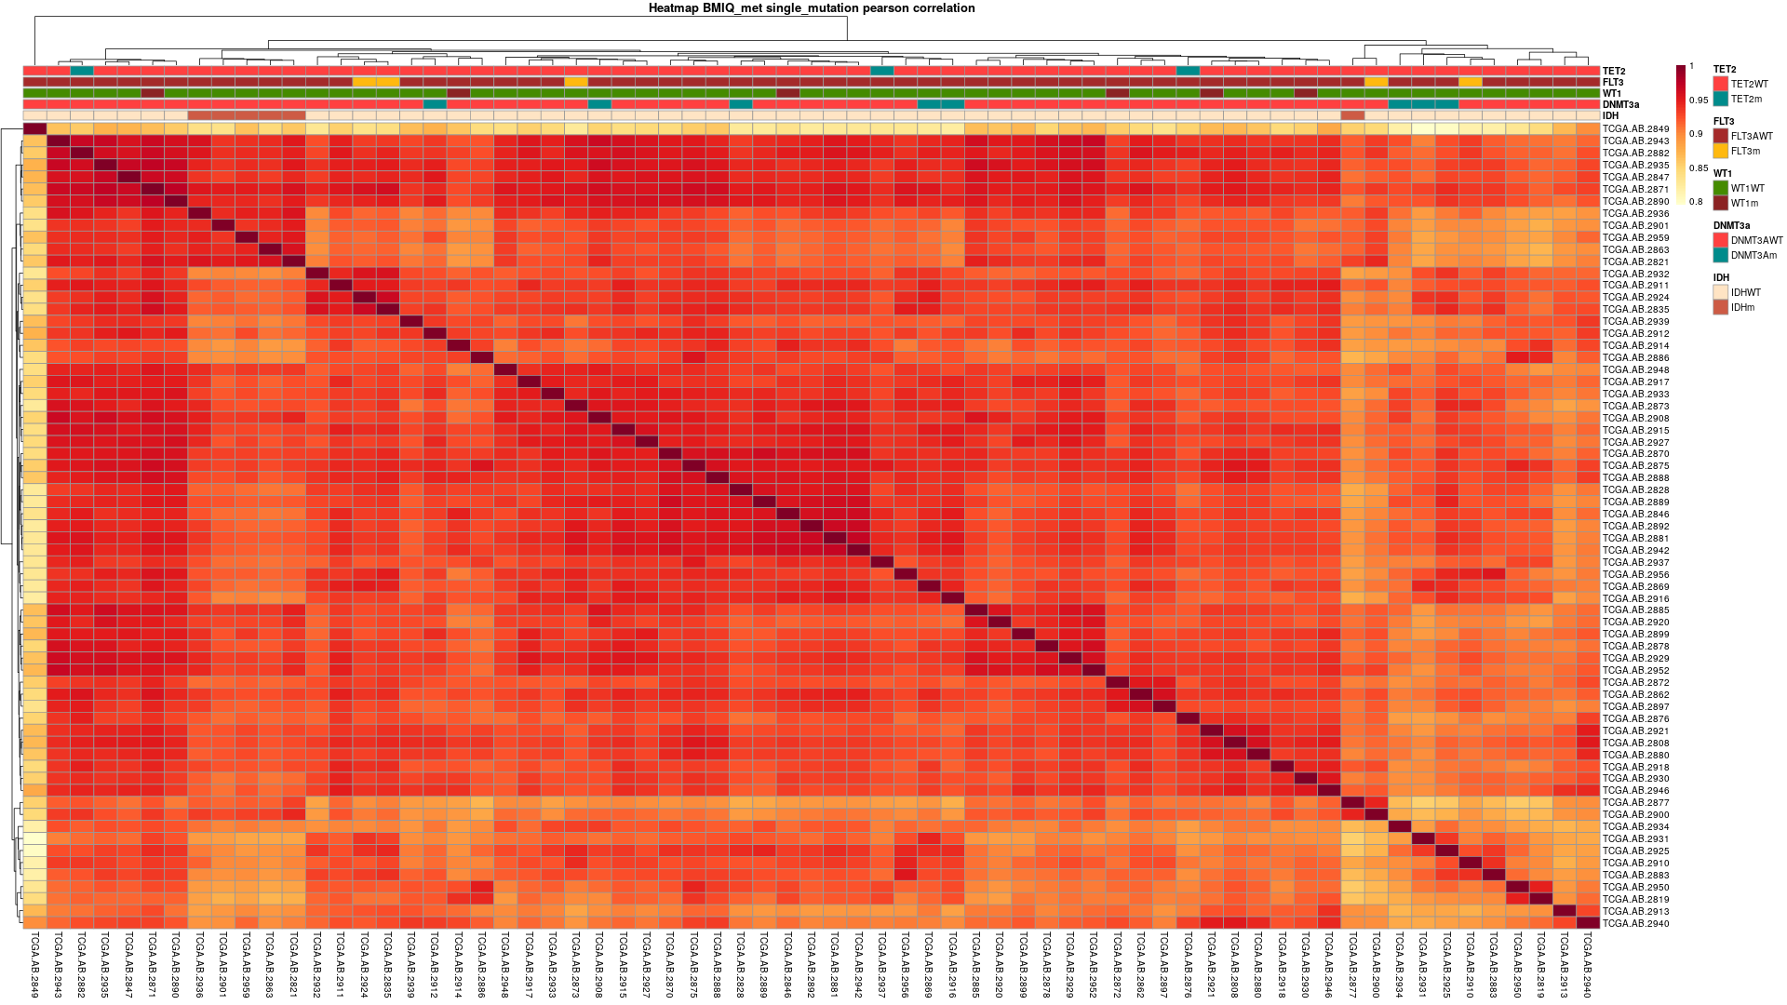
Here I wanted to see if the profil of the different mutations can cluster each other. For IDH, except for one patient, mutated IDH patient are very close together. It is possible that some patient without IDH, WT1, TET2, FLT3 or DNMT mutations have other mutations that impact the methylome.

Heatmap without WT and single mutations

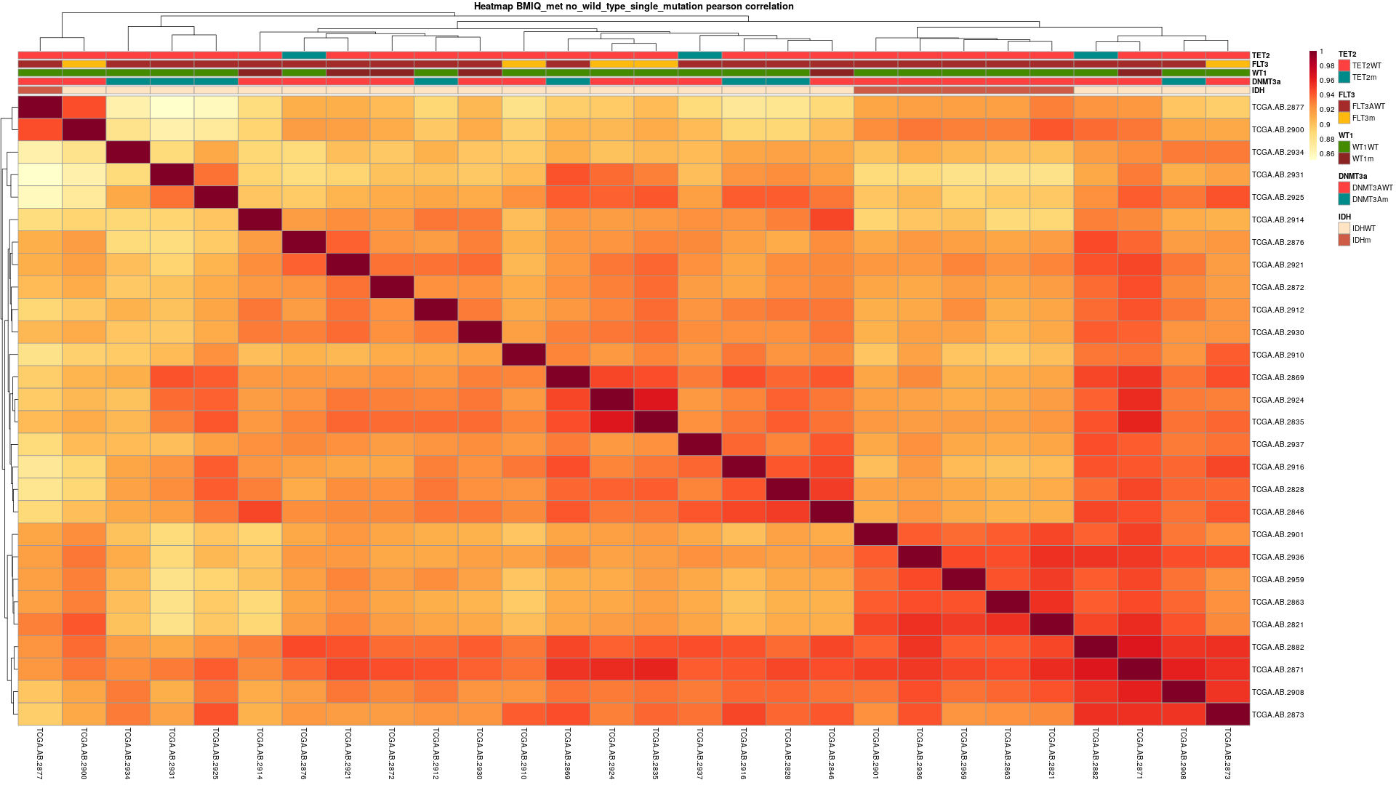

Here is the heatmap without those “WT”.

To determine if there is a global shift in methylation between mutated and WT, I made a PCA (principal component analysis) and some volcanoplots.

PCA of Methylation
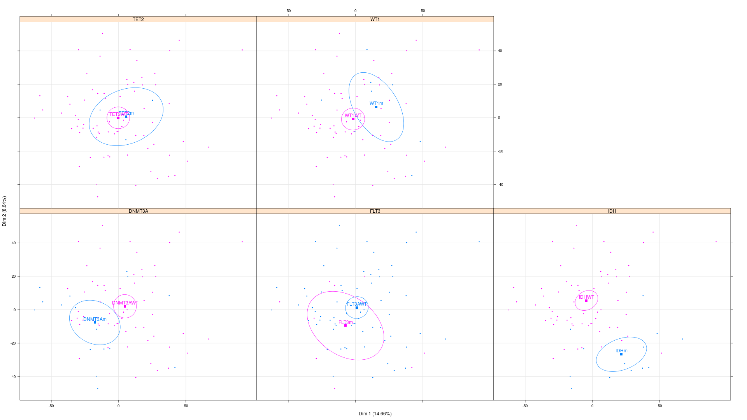
Looking at PCA: DNMT3A, WT1 and IDH have a global shift in their methylations.

Volcano plot of methylation

IDH

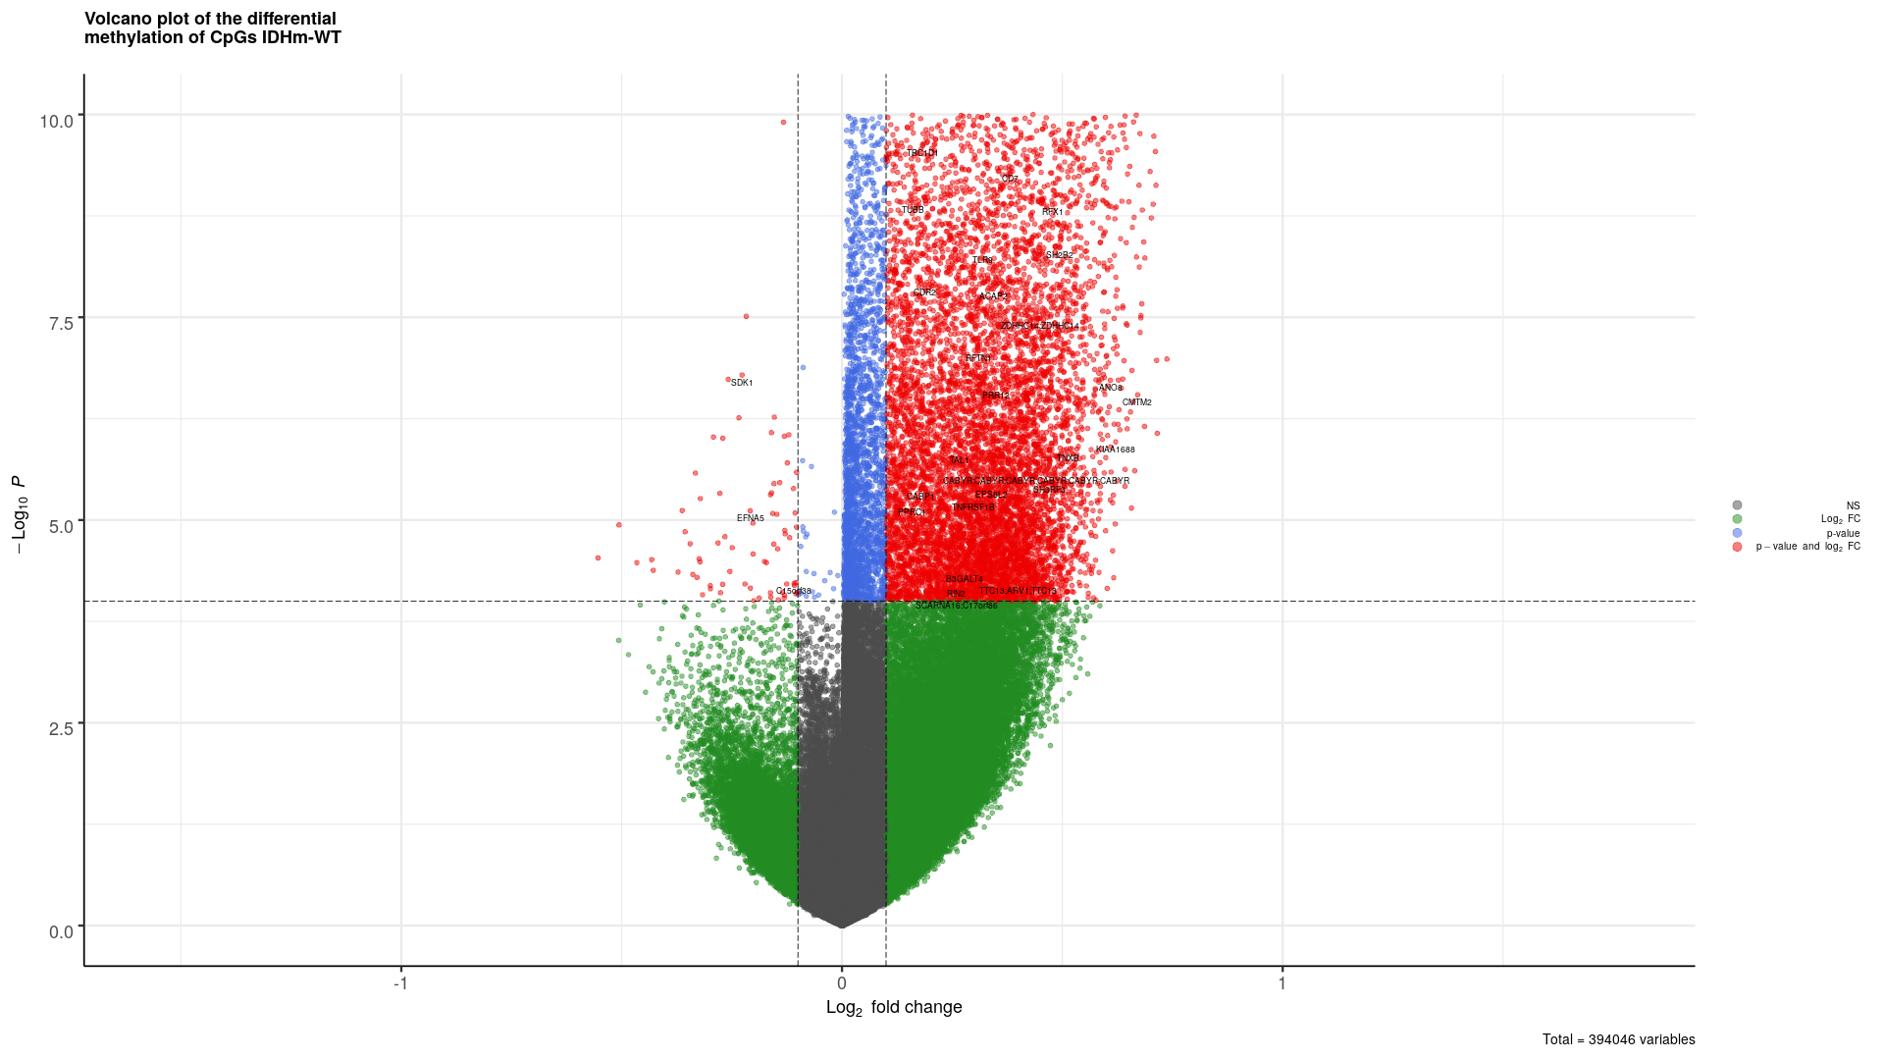

For IDH, we can see the global hypermethylation profil expected.

DNMT3A

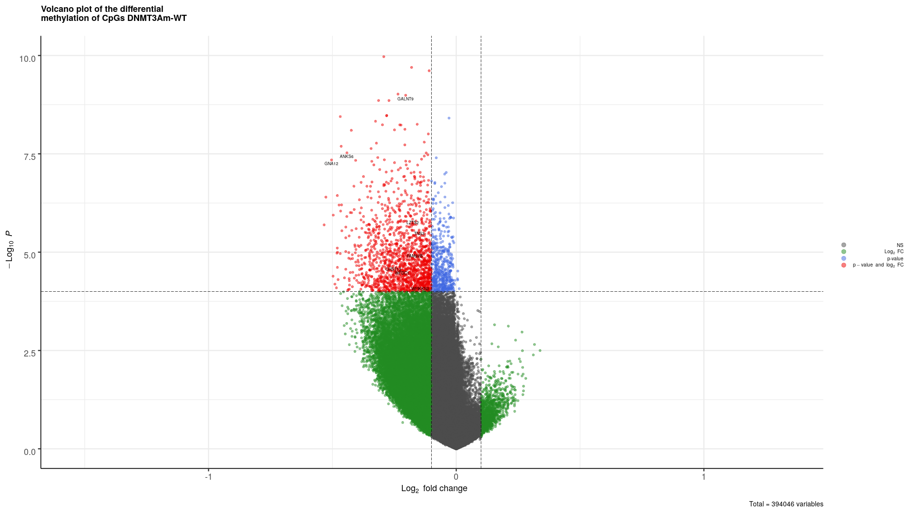

Here we can see the overall hypomethylation in DNMT3Am. As DNMT3A is involved in de novo methylation, its mutation lowers its activity leading to the lack of methylation.

WT1

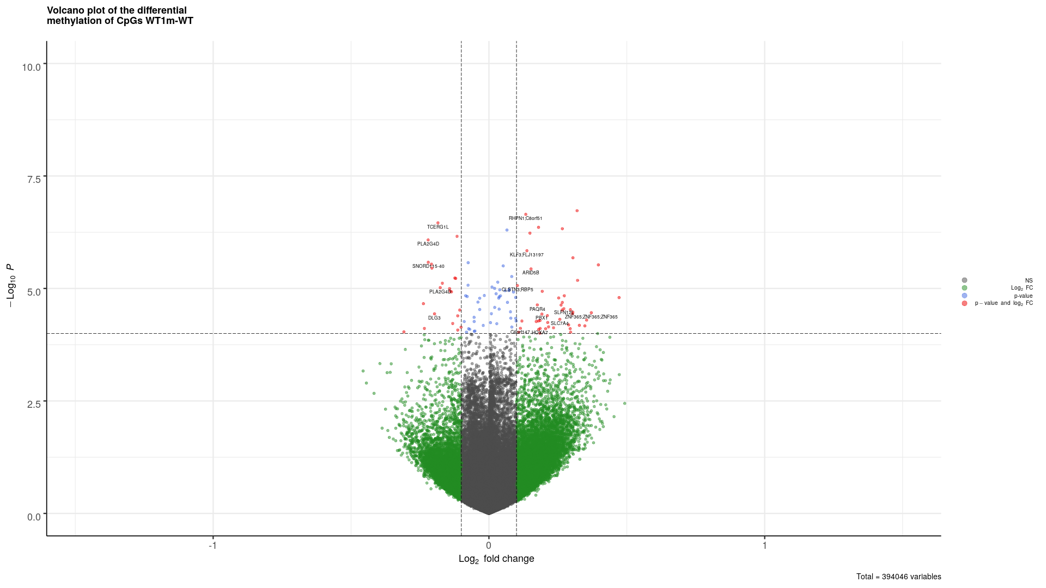
WT1 is a transcription factor that recruits TET2 to demethylate the DNA. Here we can barely see this by the slight hypermethylation of the CpGs.

Other comparisons

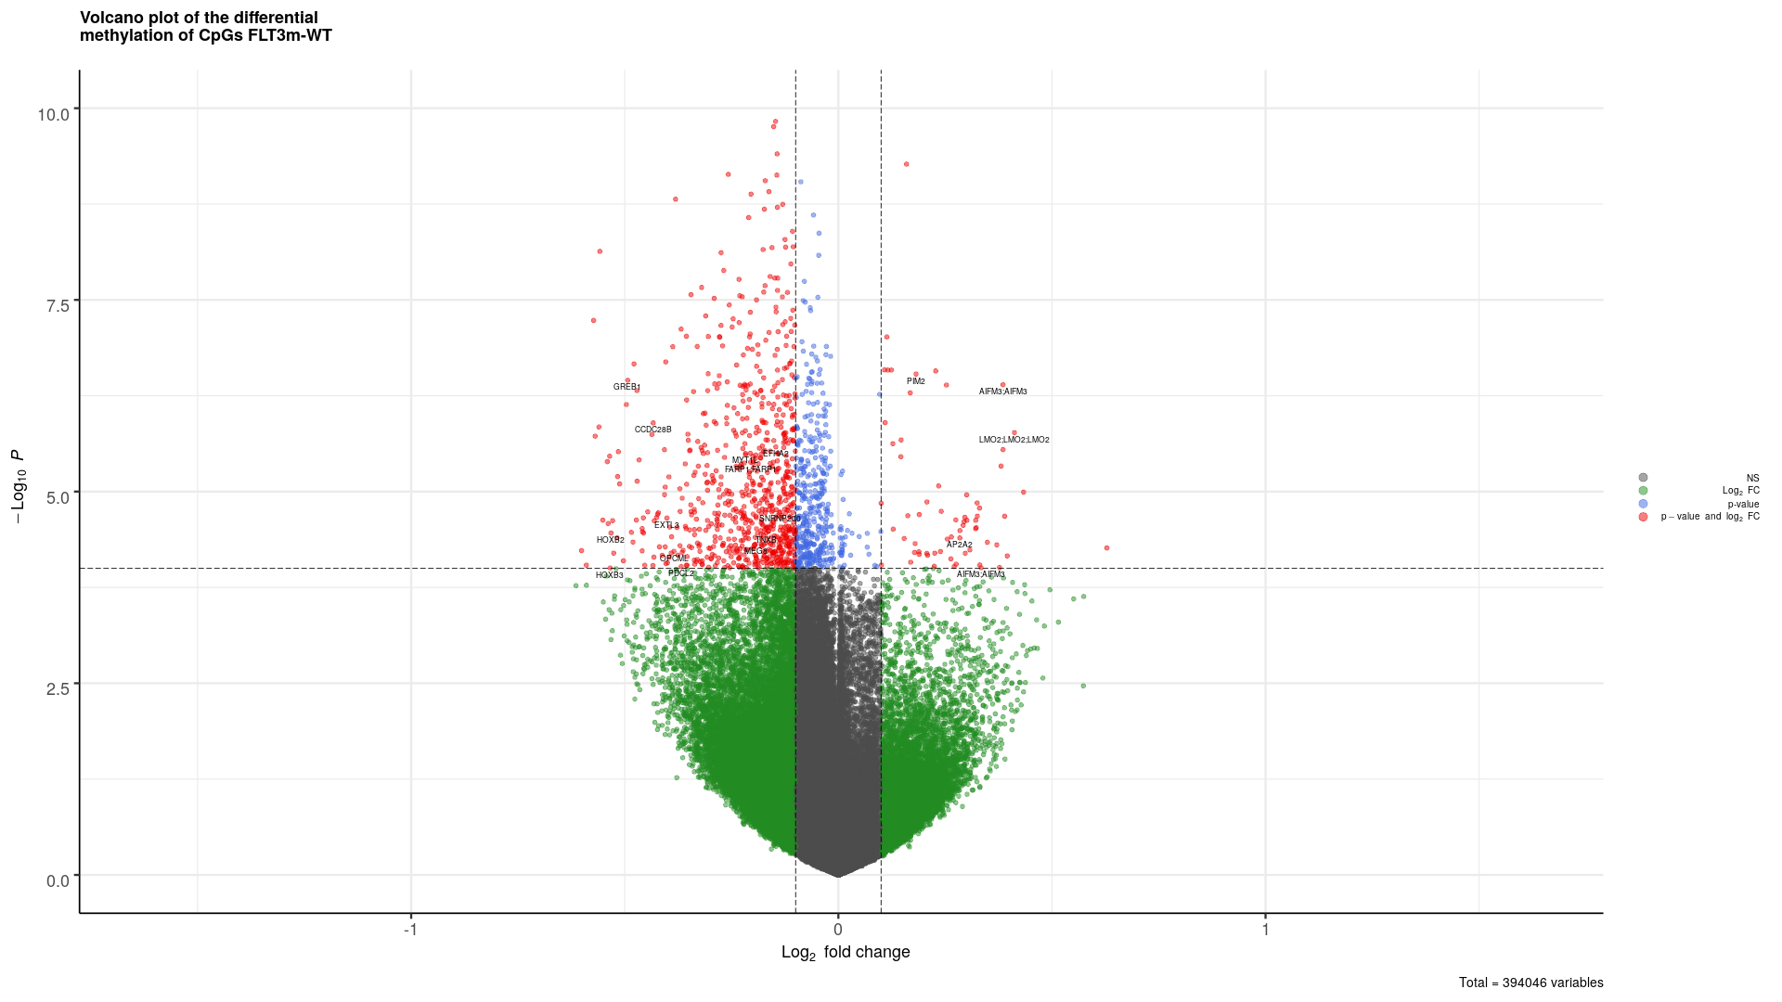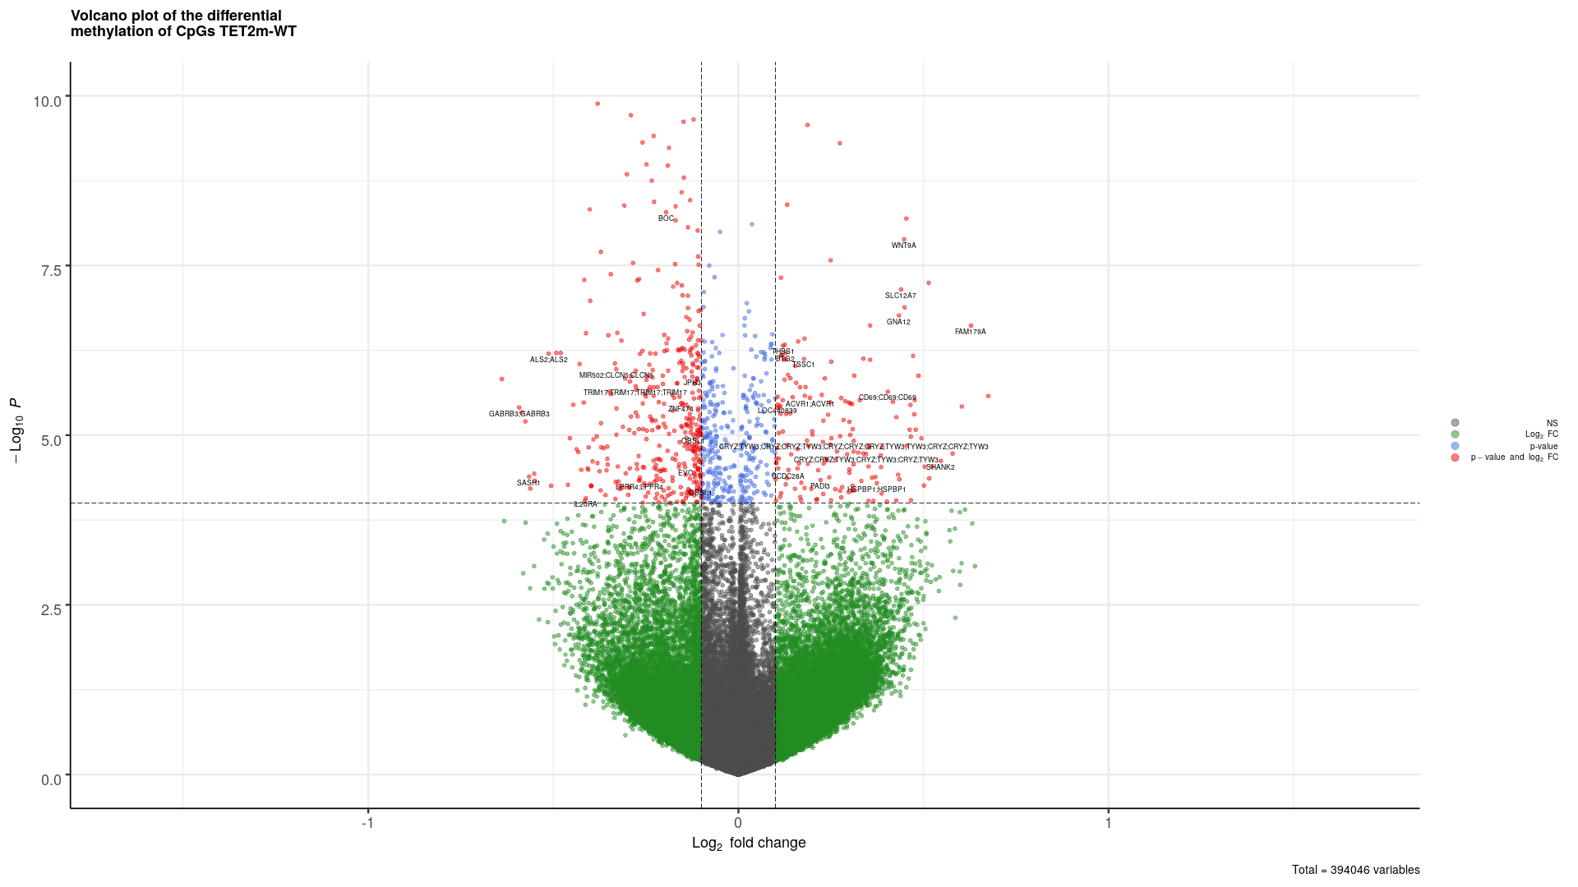
FLT3 TET2

Transcription analyses

Heatmap with WT and single mutations
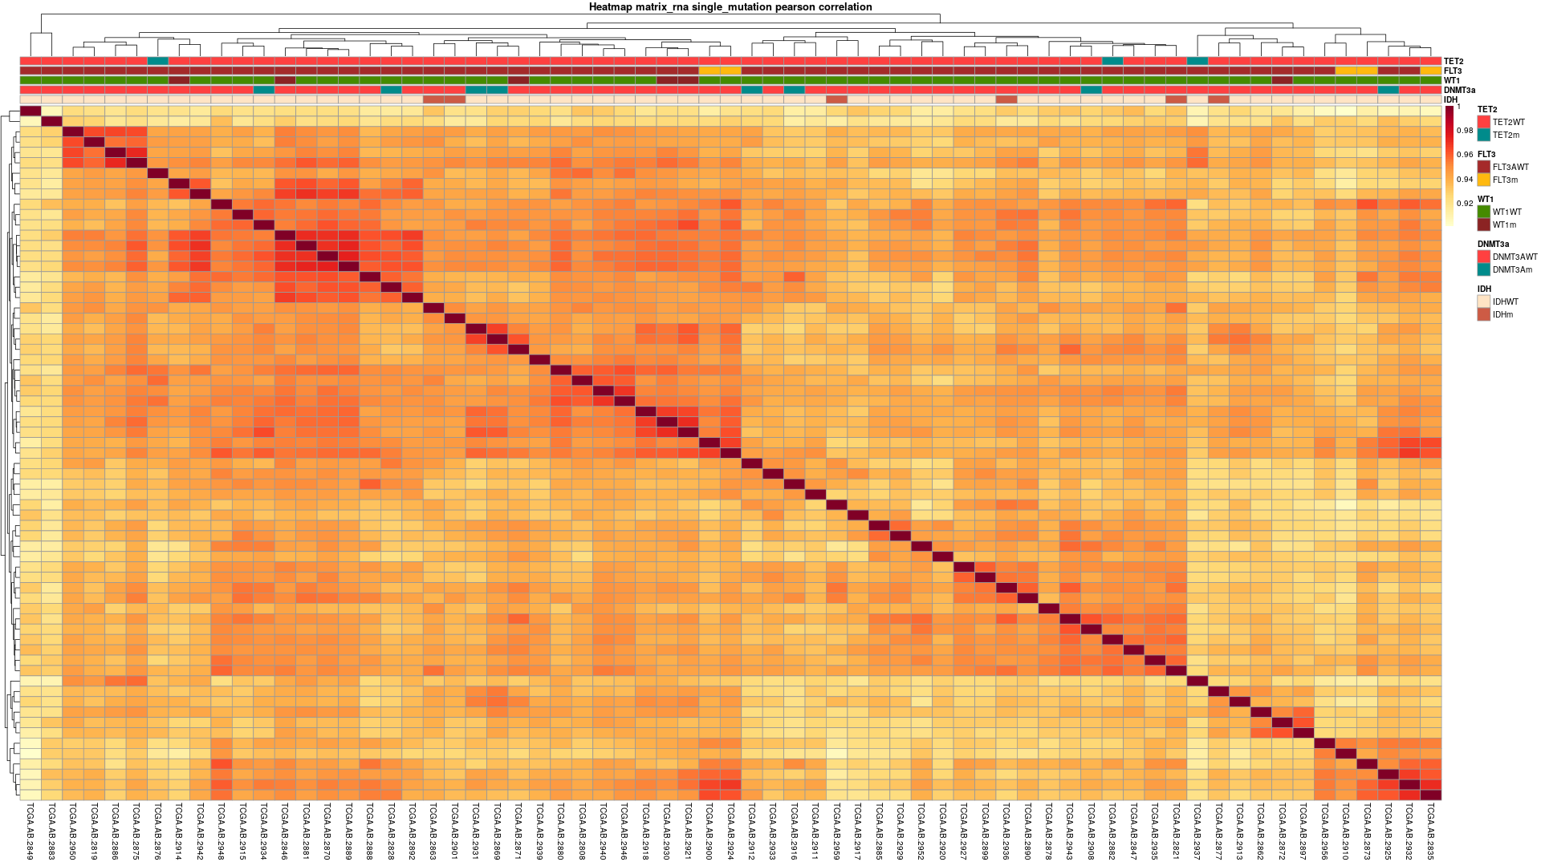

Heatmap without WT and single mutations

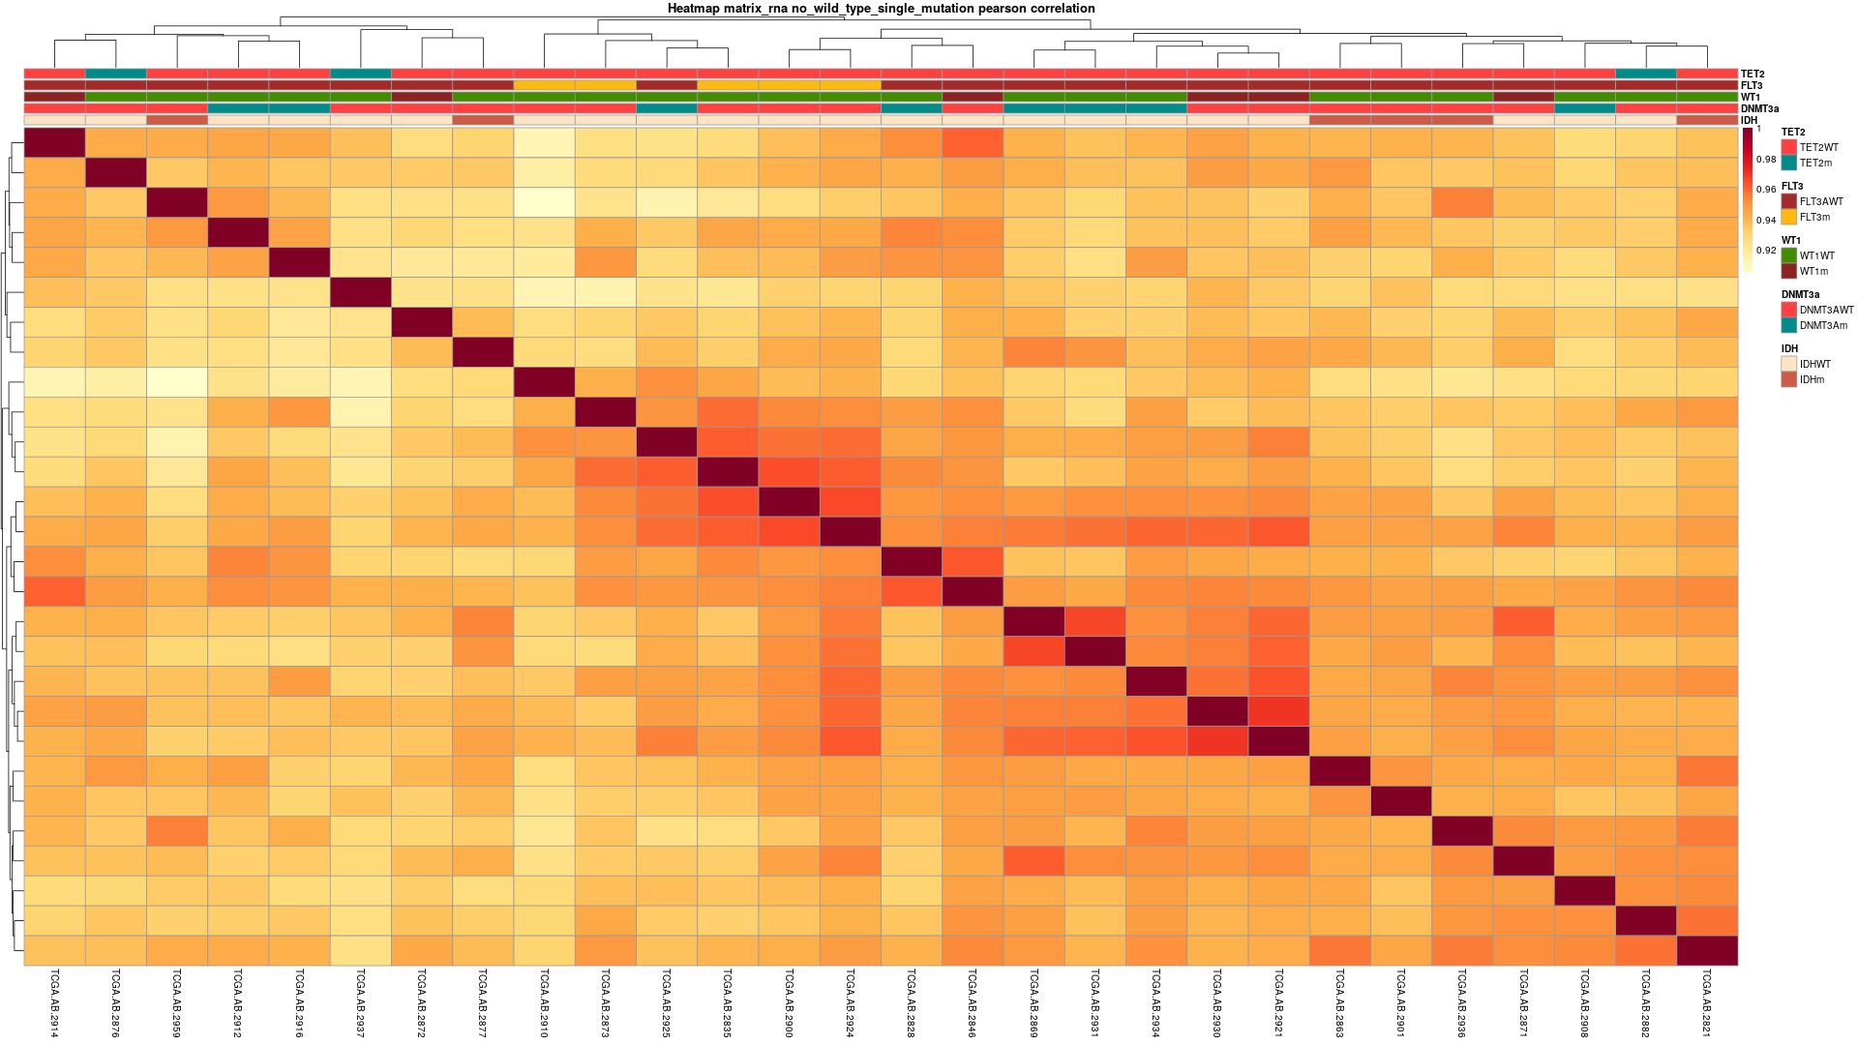

PCA of Transcripts

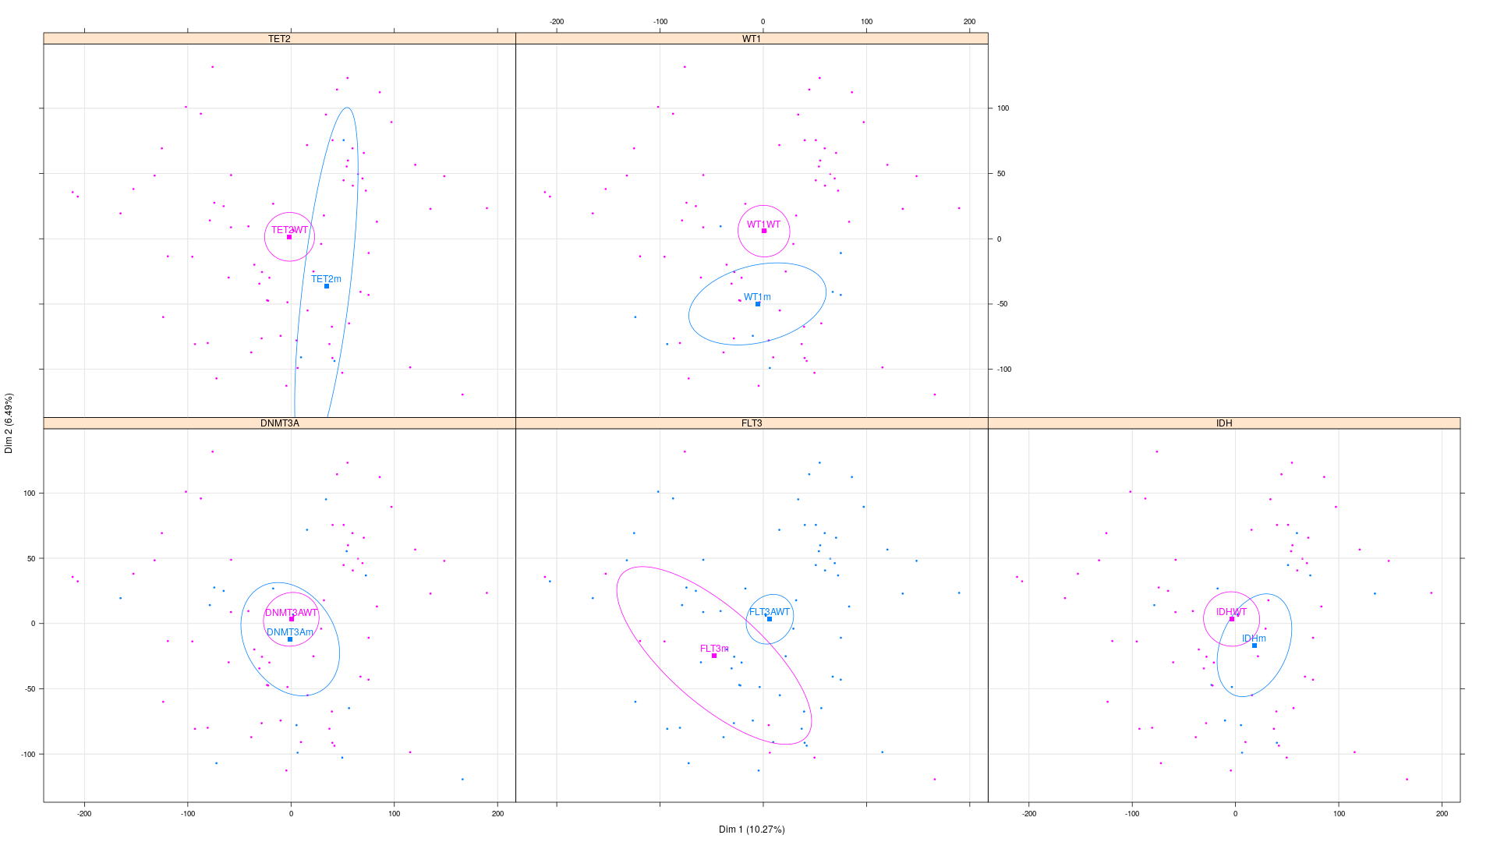

Gene Ontology analyses

IDH (links to the table UP & DOWN)

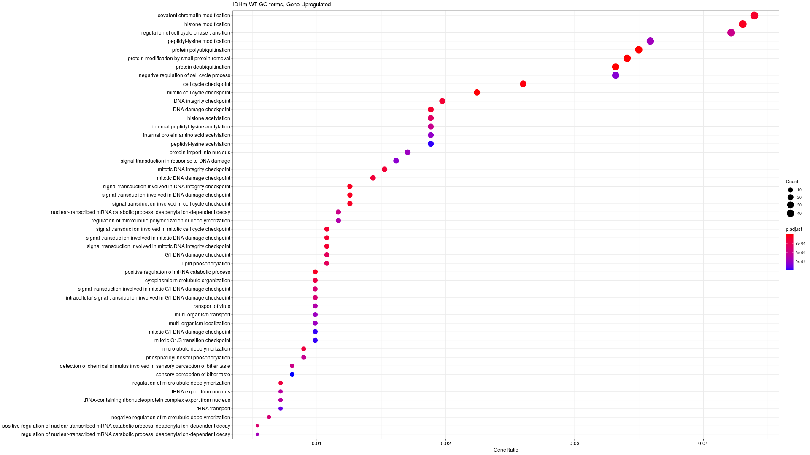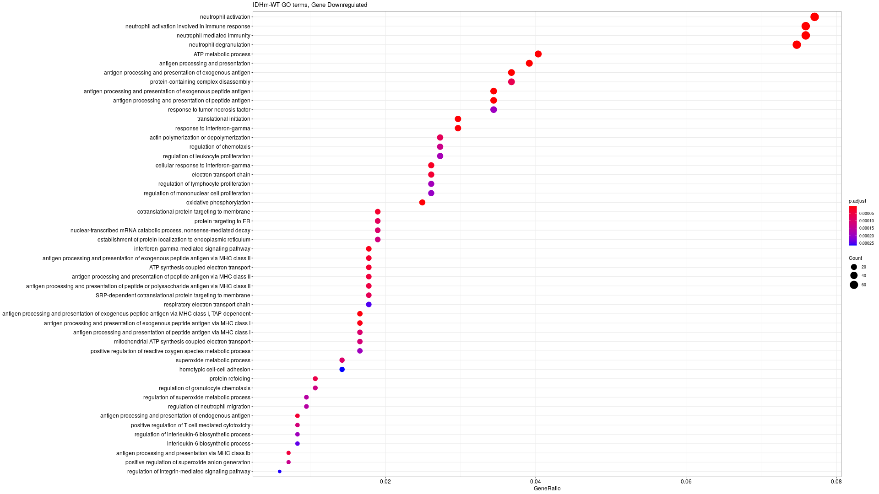
Briefly, in IDH the gene ontology analysis of the ones that are up regulated in mutant we can see a lot of pathways involved in epigenetics like DNA damage, histone acetylation or chromatin modifications
In gene down regulated, a lot of pathway are linked to mitochondrial metabolism. Electron transport chain, oxidative phosphorylation, mitochondrial ATP synthesis coupled electron transport etc.

Table of the Genes Differentially expressed

DNMT3a
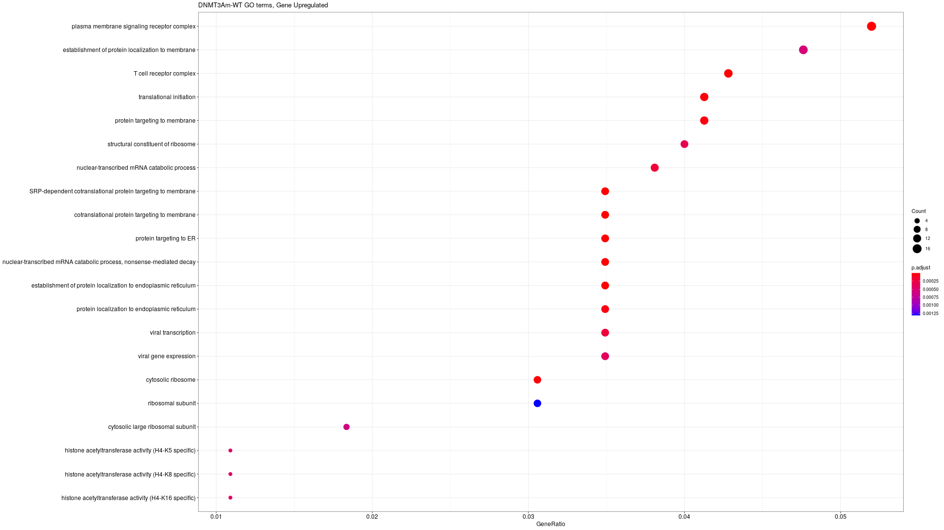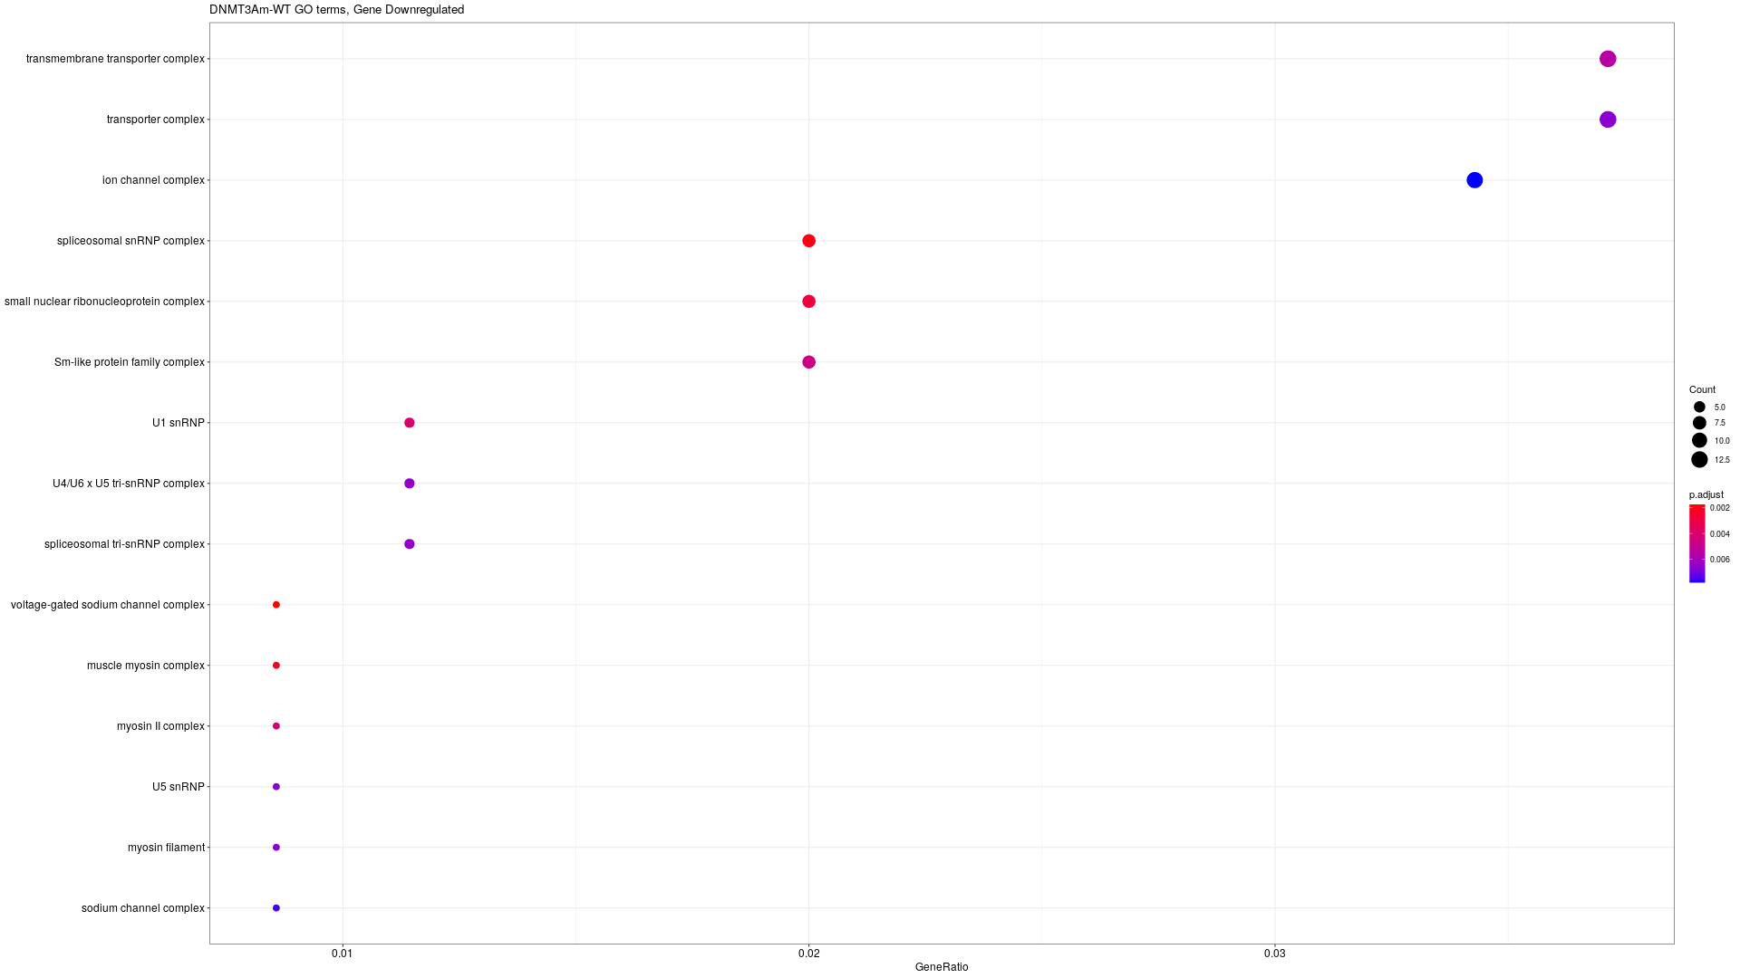

TET2m
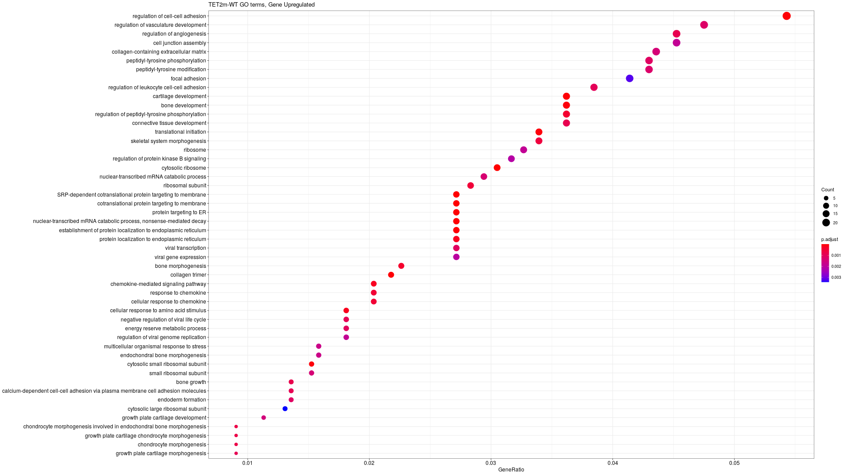
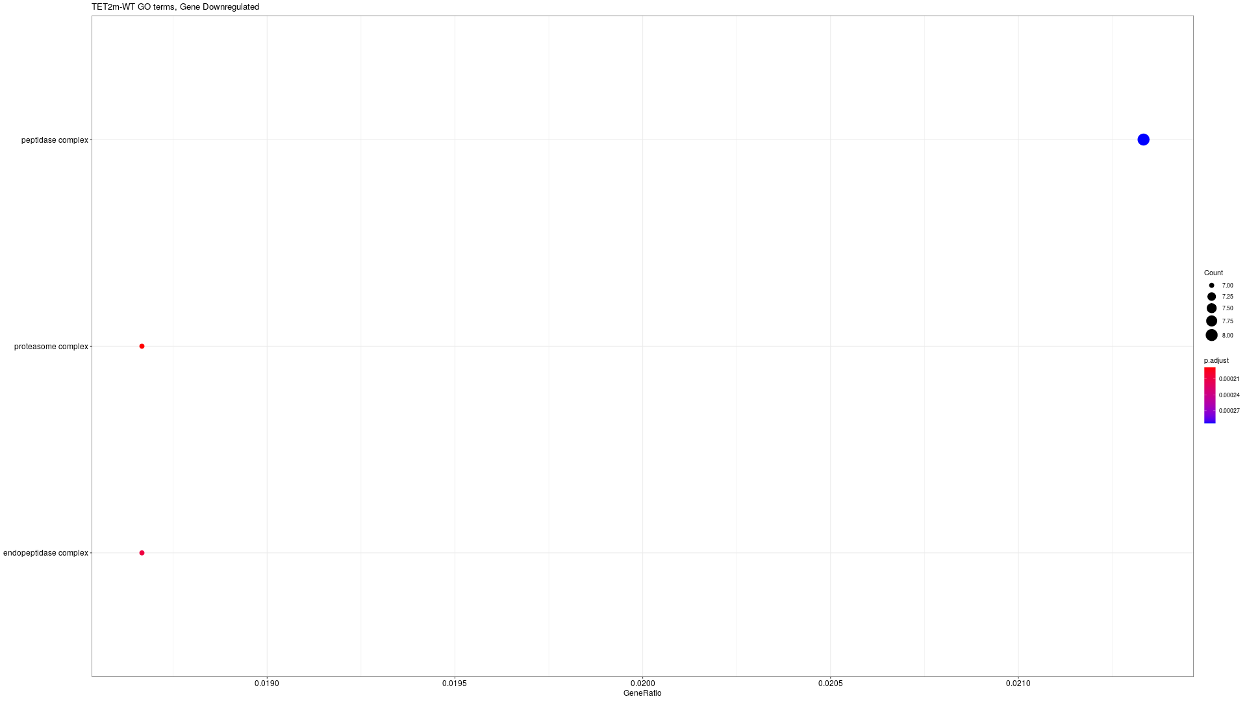

FLT3m
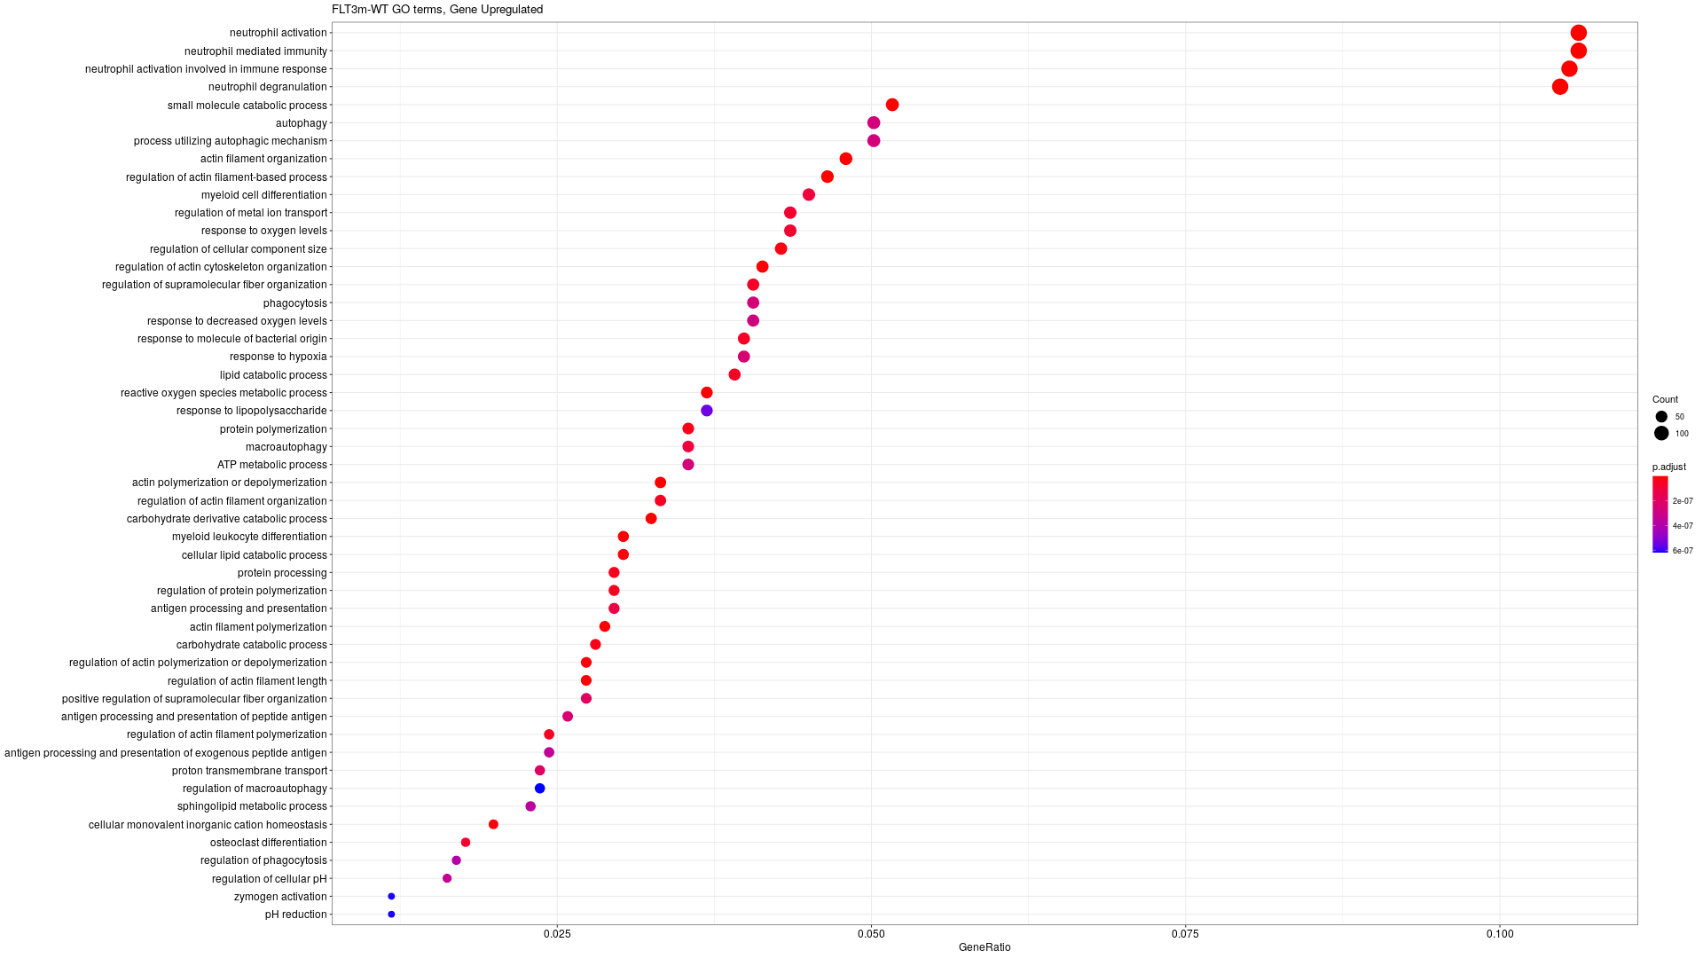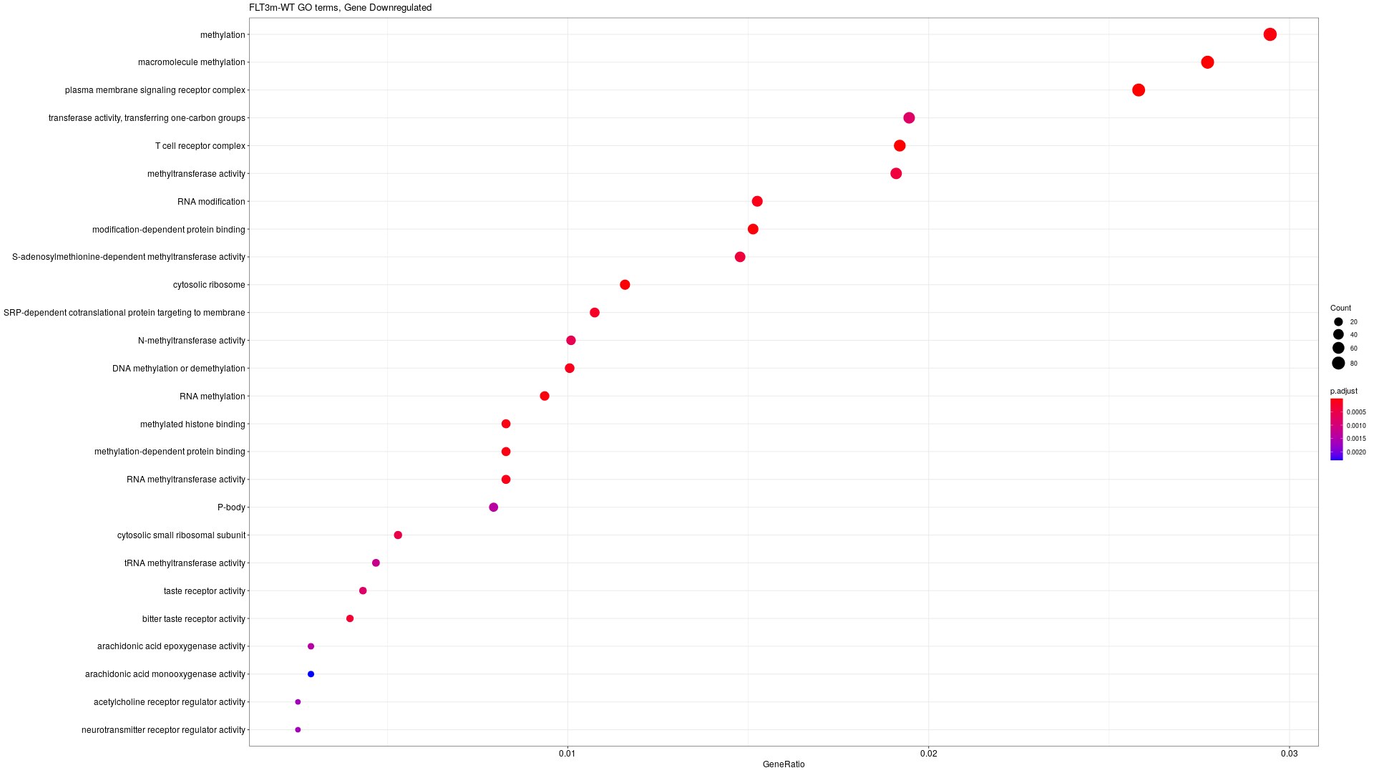

WT1m

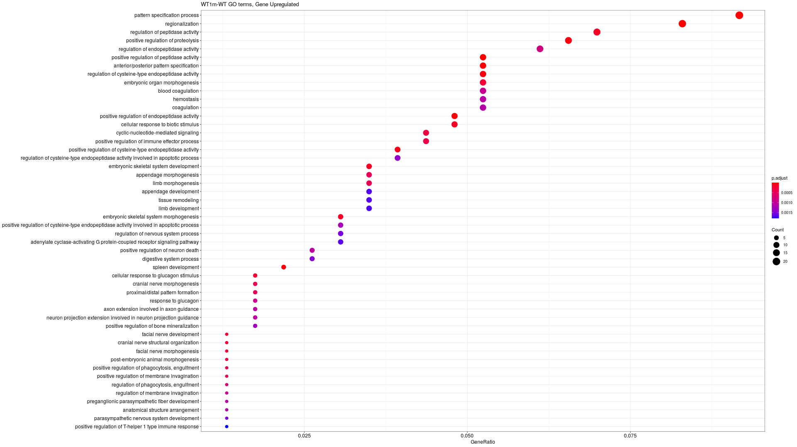

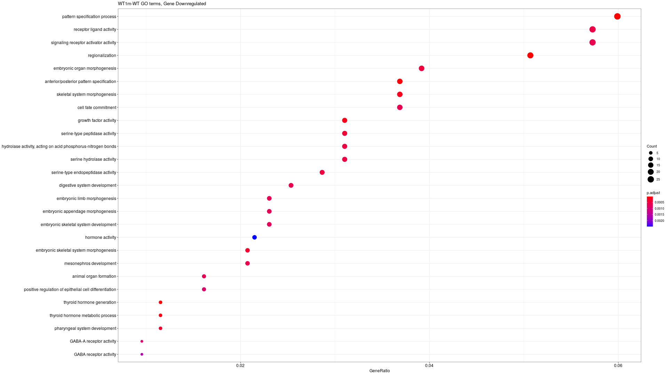

Some data (Link for the table)

 | IDH |  | DNMT3A |  | TET2 |  | FLT3 |  | WT1
CpGs DM |  | 9928 |  | 1187 |  | 2746 |  | 1463 |  | 314
Genes with promoter with CpGs DM |  | 7485 |  | 960 |  | 1818 |  | 855 |  | 296
Genes DE |  | 625 |  | 184 |  | 668 |  | 1995 |  | 246
Genes DE with promoter DM |  | 68 |  | 3 |  | 16 |  | 29 |  | 2
Genes UP with CpGs DOWN |  | 3 |  | 11 |  | 10 |  | 36 |  | 0
Genes DOWN with CpGs UP |  | 85 |  | 1 |  | 7 |  | 12 |  | 2
Genes with promoter in the neighbor of CpGs DM |  | 15929 |  | 4003 |  | 5946 |  | 4010 |  | 1497
Genes DE with promoter in the neighbor of CpGs DM |  | 224 |  | 30 |  | 77 |  | 181 |  | 9
Genes DOWN in the neighbor of CpGs UP |  | 63 |  | 0 |  | 5 |  | 23 |  | 7
Genes UP in the neighbor of CpGs DOWN |  | 3 |  | 8 |  | 7 |  | 20 |  | 0
Proportion Gene DE in neighbor of CpG (%) |  | 68,96 |  | 38,04347826 |  | 13,47305389 |  | 14,3358396 |  | 6,097560976

IDHm has a much more differences in methylations. (logFC > 0.3)

More than the ⅔ (68.96%) of the genes differentially expressed are connected to fragment differentially expressed. This proportion is lower in other comparisons.

List of the genes UP regulated with CpGs DOWN methylated in IDH
CLIC2, F2RL1, PCDHB15

List of the genes DOWN regulated with CpGs UP methylated in IDH
"ABI3", "ACY3", "ADGB", "AGTRAP", "AK8", "ANGPTL6", "C1QTNF4", "C20orf197", "C5AR2", "CACNA2D4", "CD1D", "CD300C", "CD300LB", "CD300LD", "CD93", "CD96", "CDA", "CEBPE", "CIDEB", "CLC", "CLEC11A", "CMTM2", "COL9A2", "CX3CR1", "CXCR2", "DAPL1", "DHRS3", "FBP1", "GALC", "GP9", "GTSF1", "HCG11", "HENMT1", "HLA-DMB", "HLA-DPA1", "HLA-DPB1", "IL12RB1", "IL27", "IL2RG", "KCNMB1", "KLHDC7B", "LDLRAD2", "LGALS3BP", "LILRA4", "LINC00649", "LRG1", "LST1", "LTK", "LY86", "LY86-AS1", "MACC1", "MAG", "MAP10", "MEFV", "MPZL2", "MS4A3", "NME3", "PDLIM1", "PHYHD1", "PTH2R", "PTX4", "QPCT", "RNU6-501P", "S100B", "S100P", "SEMA4A", "SEMA6B", "SERP2", "SIGLEC7", "SIGLEC9", "SLC37A2", "SLC9A3R2", "SLFN13", "SPATA12", "SULT2B1", "SUSD3", "TARM1", "TBC1D9", "TNF", "TNNI2", "TNNT3", "UTF1", "VSTM1", "ZNF185", "ZNF385A"

Genes potentially down regulated by enhancer up methylated in IDH
"ACOX2", "ADAMTS15", "ALPK3", "ARHGAP31", "ARTN", "C1orf127", "CACNA2D4", "CCDC149", "CD1B", "CD1D", "CD300LB", "CDK15", "CKM", "CLECL1", "CXCR2", "DYDC2", "ELOVL3", "FAM205A", "GGT1", "GLOD5", "GPBAR1", "GPR55", "GPRC5C", "HLA-DMB", "HLA-DPA1", "HLA-DPB1", "HLA-DQA1", "HLA-DRA", "HORMAD1", "IFI27L2", "KCNK6", "KYNU", "LAMB3", "LOXHD1", "LRRC25", "LRTM2", "MAP10", "MMEL1", "MNDA", "MYO7B", "NKAPL", "NPL", "OSCP1", "PHYHD1", "PRG2", "PTAFR", "RASSF4", "RGS10", "RNU4-27P", "RNU6-1042P", "ROGDI", "RPS6KL1", "SIGLEC12", "SIGLEC7", "SIGLEC9", "SIGLECL1", "SIPA1L2", "SLC2A6", "SMIM22", "ST14", "TMEM150B", "TNFSF15", "TYROBP"

Genes potentially up regulated by enhancer down methylated in IDH
"PCDHB15", "PCDHGB4", "PGAP1"

All the genes, their expression and the value of methylation of CpGs in their promoter

Deconvolution analysis (Link to table)

The analysis on deconvolution showed that some patient data have a lot of Macrophages M2 in their sample analysis. Other patient have a large majority of uncharacterized type of cell.

Network visualisation (IDH analysis)

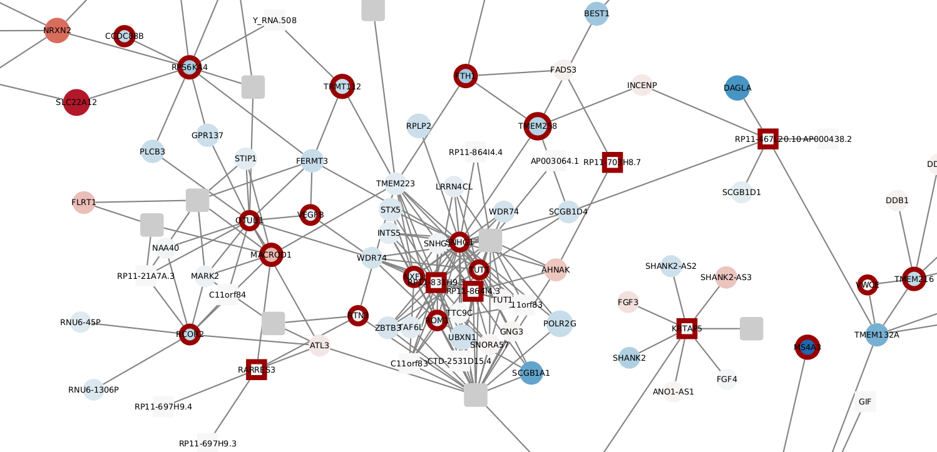

Blue nodes = Down regulated genes
Red nodes = Up regulated genes

Blue border = Down methylated fragment
Red border = Up regulated fragment

Circle are Promoters
Square are other ends

Edges are 3D contacts

Problem with visualisation:
- Some promoter are link to multiples genes but are named only with one of them (CEBPa for example is CTD-2540B15)

